Aim:- IOT based MCB switcher

Objective:-
- It should send mail or send an alert when mcb is tripped.
- I Should be able to operate(ON and OFF) from mobile.

process:-
Switch case:-(switch Holding plate)
- A hollow rectangular plate having length and breadth of 45X17mm(of hollow part,
- Having 3 sections upper, middle and bottom.
- Basically creating switch section using nails and this mechanical plate
- Plate will be attached on the switch
- The switch can be pulled up using this plate, by attaching the actuator above it.
- image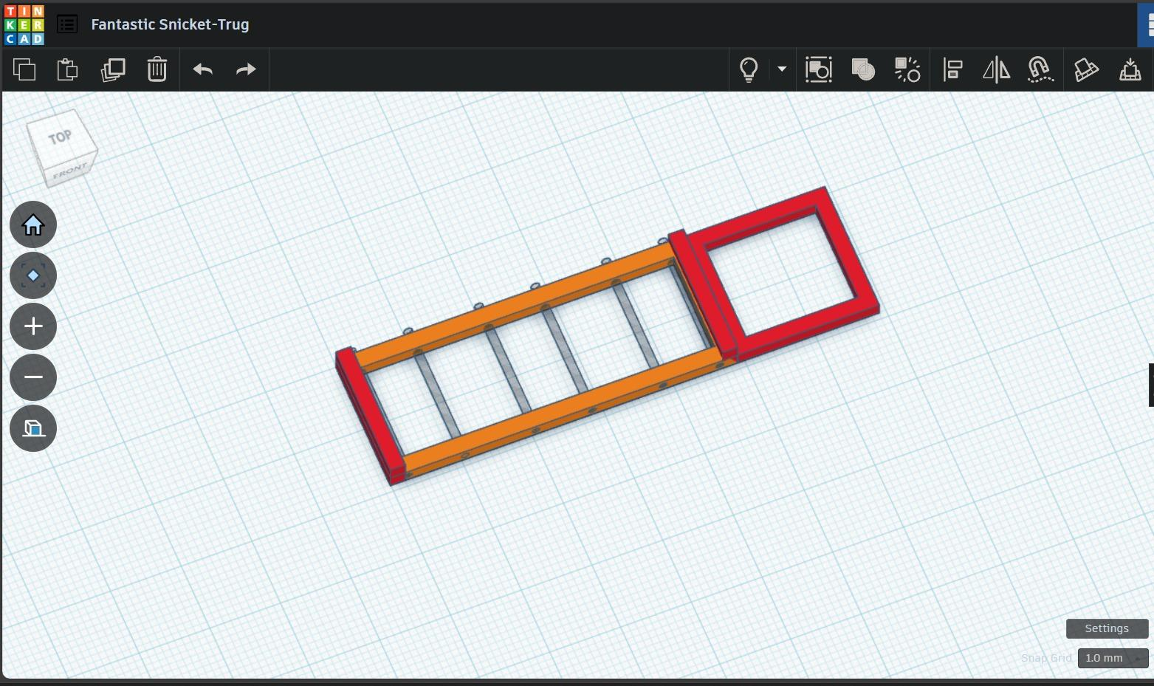

Detection method:-
- Detection will be also done by using this plate only
- Using pull up switch machinism
- Output High and low

Pull up method:-
- Pulling it up using linkage and servo
- Dropped plan because of sudden retripping and back drivable srevo
- Also it was complicated and more chances of failure.
- Next way by using linear actuator By servo motors.

Trials for pullup methods:-
- Tested the servo by using weight lifting method,
- Weight required to lift the switch was 516 grms(approximately tested)
- Trial of servo SG90- highest weight it was able to lift was 230gms that also with low speed
- So dropped plan of using SG90
- Also, destroyed 2 SG90 while testing.
- Trial of servo MG90- highest weight it was able to lift was 348gms.
- So I dropped the plan of using an MG90 servo motor.
- Testing of N20 geared motor:- It was able to lift 230gms(approx) only.
- Also destroyed one N20 geared motor.
- Testing of MG996R:- it was able to lift weight more than (approx)670gms
- MG996R was also working at highest speed
- So continued it by using MG996R servo motor
- Images of testing-
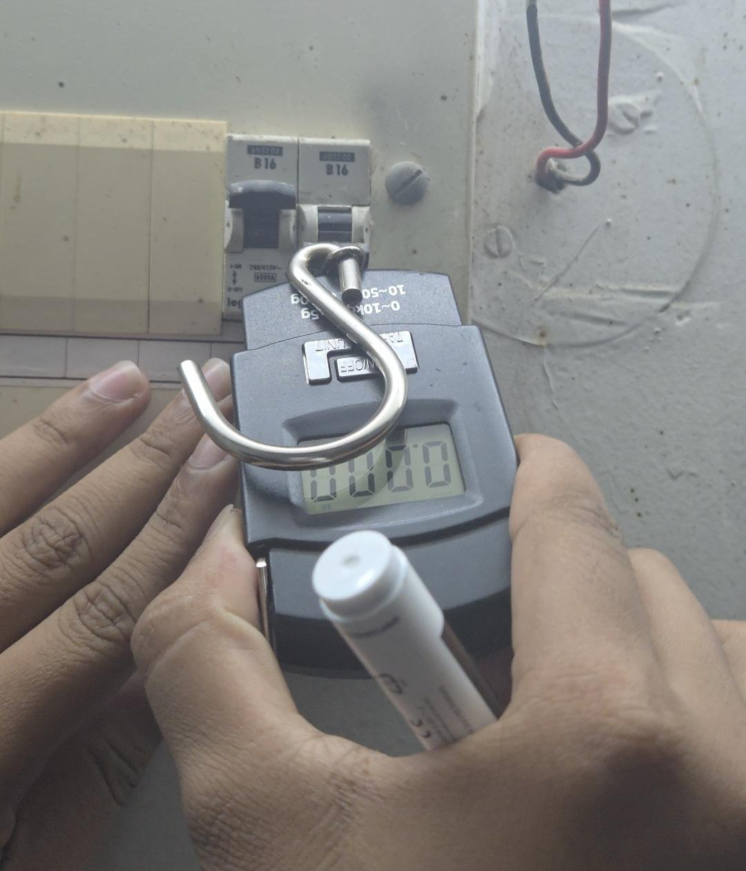

Reason of failure:-
- Dropped plan of switch holding plate.
- Because of problem with lifting process
- Complexity of linear actuator
- Hard to build
- Also improper design or any fault while shifting switch can go against the safety of mcb.

Testing by directly mounting servo:-
- Firstly mounting the servo and its pawns on holes of the servo and lifting it using a nail.
- Dropped it because of the very big size of servo and mounting issue on mcb.
- Simple method of lifting which we got on the internet(youtube) directly using pawns.
https://youtu.be/zbU3n2vJSLs
- Most reliable and easy method.
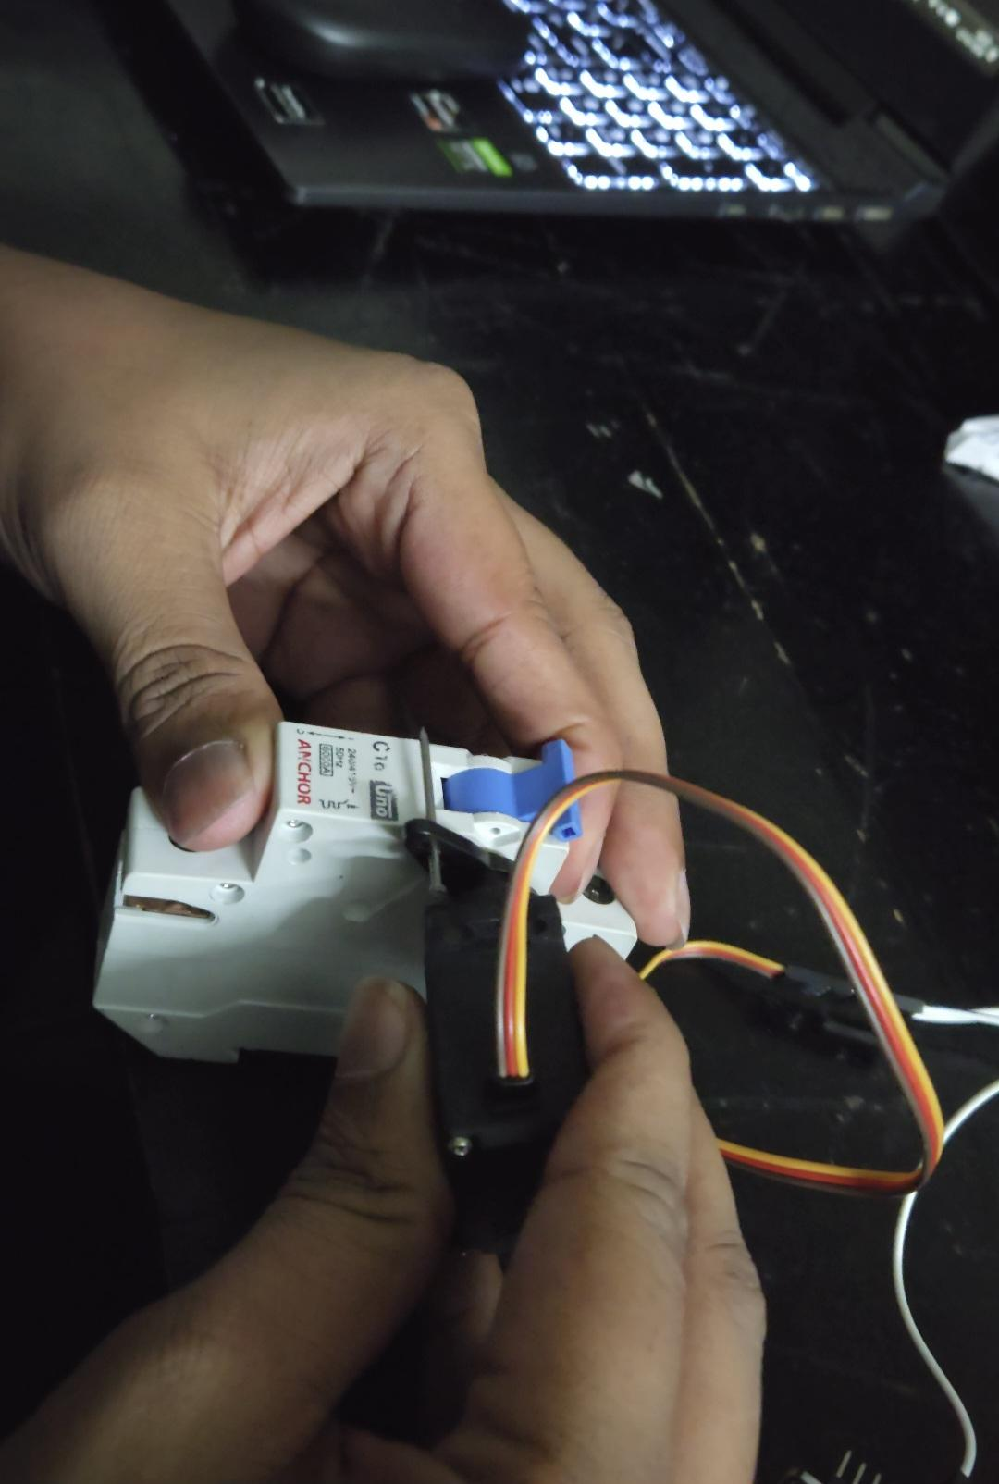
- Image or video of testing-
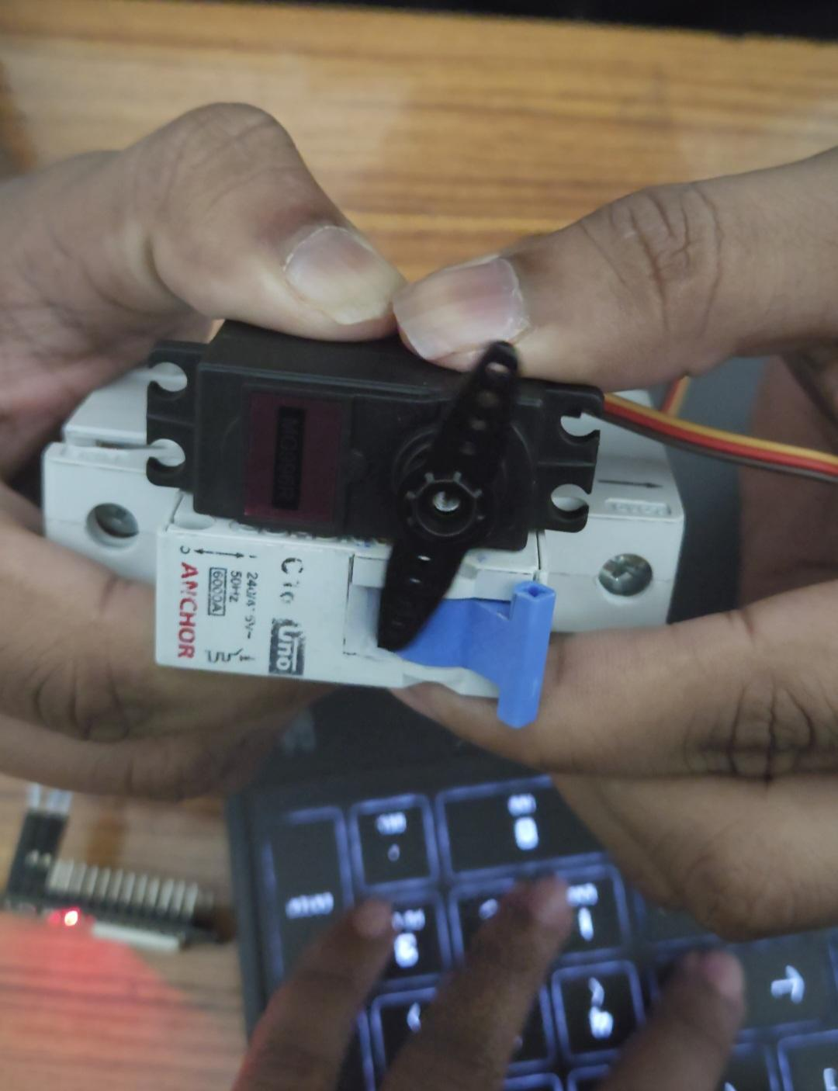
Movement of MG996R servo:-
- According to data sheet of mg999r servo motor
- Servo was able to only rotate 120 degrees, 60-0-60 degrees.
- But after practically testing it was able to move 180 degree,
- Time delay of servo motor(to make one cycle)
Servo was only able to move 90 degrees in 500 microseconds.
And below that delay it was behaving abnormally or was working very fast
For 120 degree rotation it was taking a time delay of 600.
And for 60 degrees it was taking 400 microseconds.
- So we set zeroth position of servo as 60 degree
- From 60 degrees if it goes to the original zeroth position switch will fall.
- And if in opposite direction 120 degree it will lift the switch
Design for servo case:-
- made a simple servo holding case, having c type case to hold mcb.
- image:-
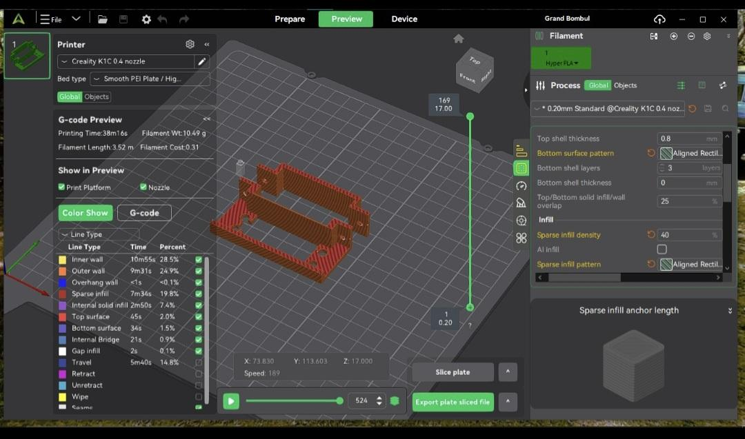

Printing of servo case:-
- image
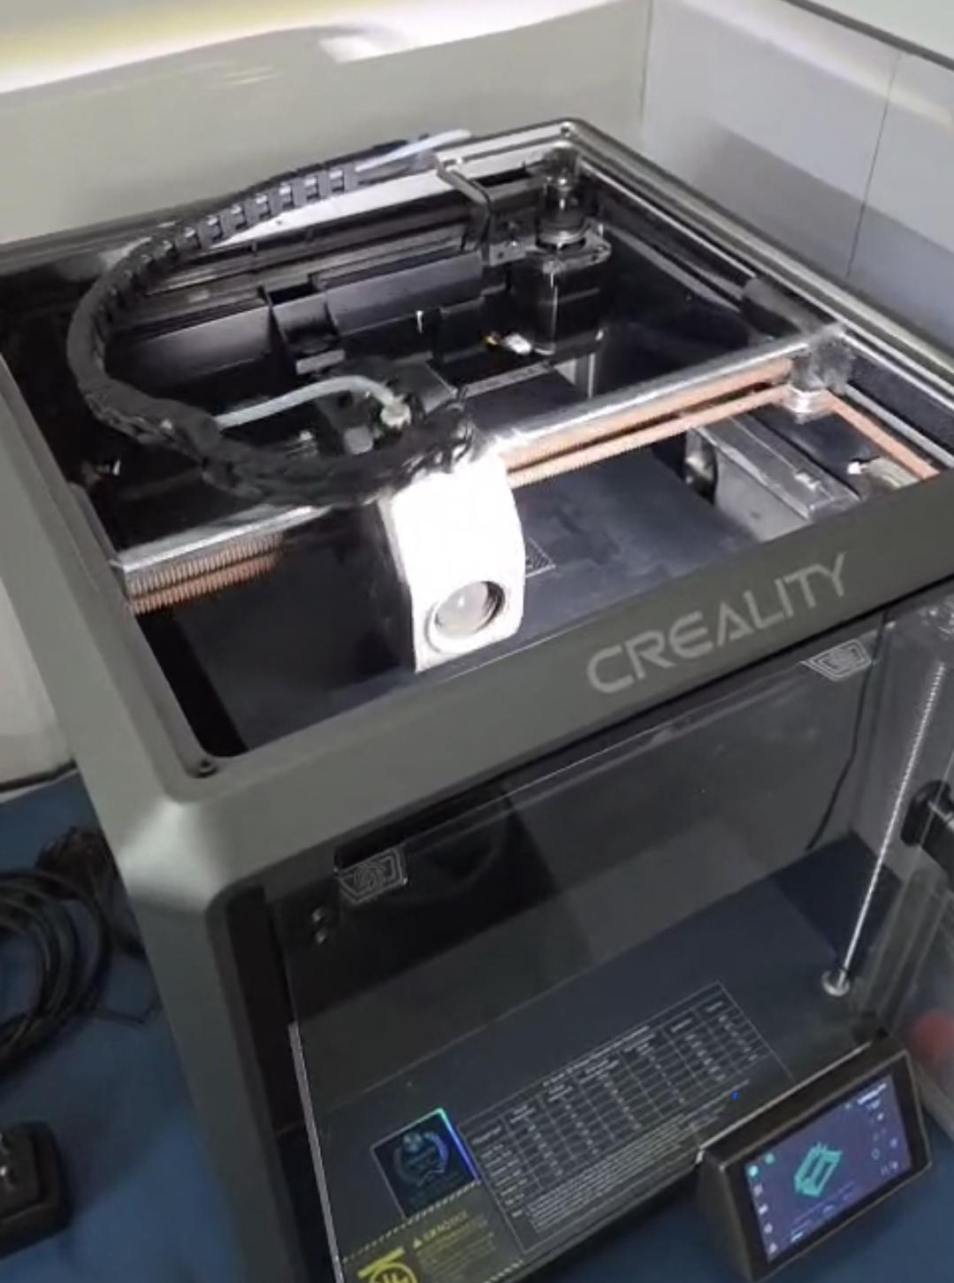

Fixing of servo in servo case:-
- Due to exact dimensions and mistakes while designing it was difficult to put servo in the case so we had to rub some part of the case using sand paper so we could properly put the servo.

Testing of servo with case:-
- Tested the servo by putting simple code.
- Servo was installed on the case very properly and was running smoothly.

Testing of Hall sensor:-
- By using A3144 hall sensor, used to detect the magnetic field.
- We made mcb trip detection using this.
- Used a magnet
- Installed the magnet on the switch.
- Image or video
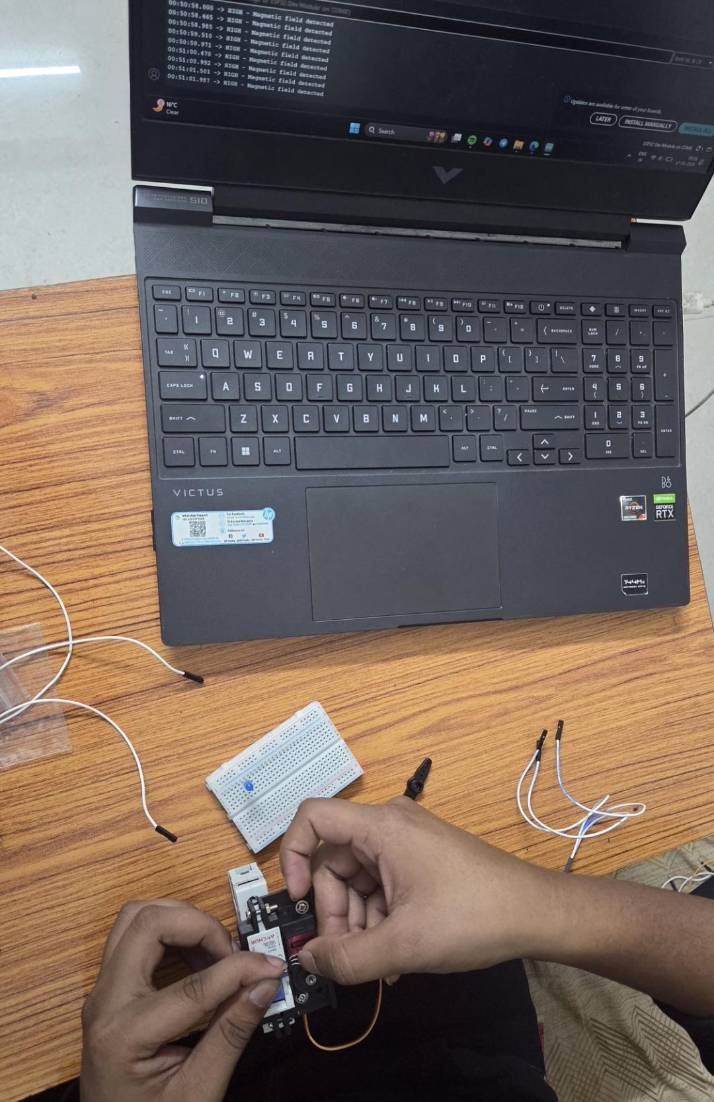

Testing of sending mail after detecting:-
- Image of mail


Testing of web-site by moving switch:-
- Image or video-
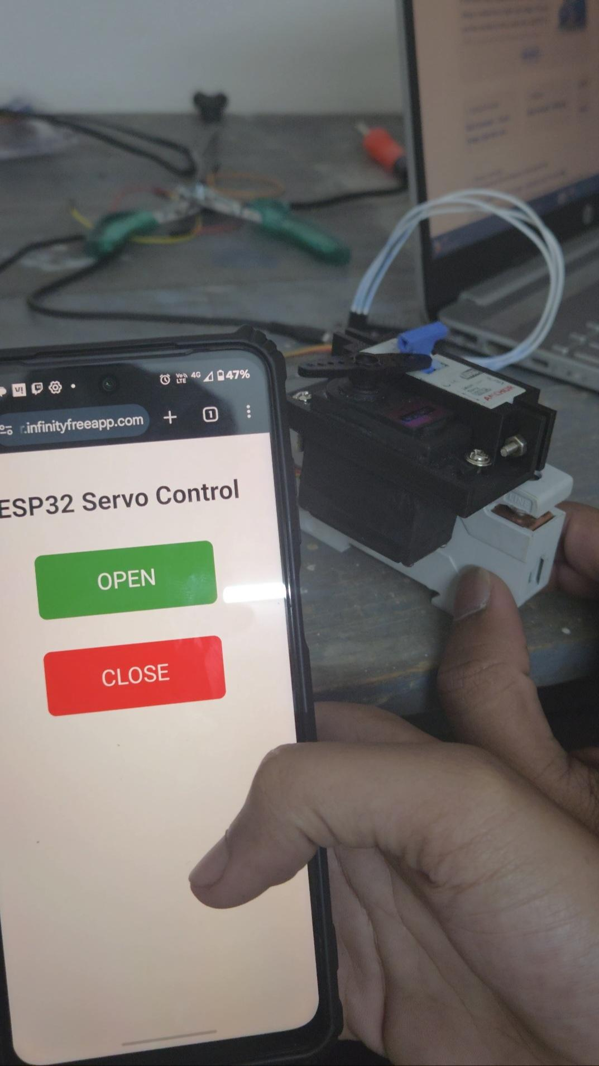

Failure after damage:-
- Due to the damage to product after dropping it from some hight,
- It was not working properly and we had to make it again
- Tried to restore it by applying glue but it was a complete failure.
- Image or destroyed part-
- Also we destroyed the hall sensor while soldering.
- Image of sensor-
- So after buying new sensor one problem occurred
- Hall sensor was giving opposite values, firstly it was giving high after detecting magnet, but now it was low whole process was going in opposite way
- image -
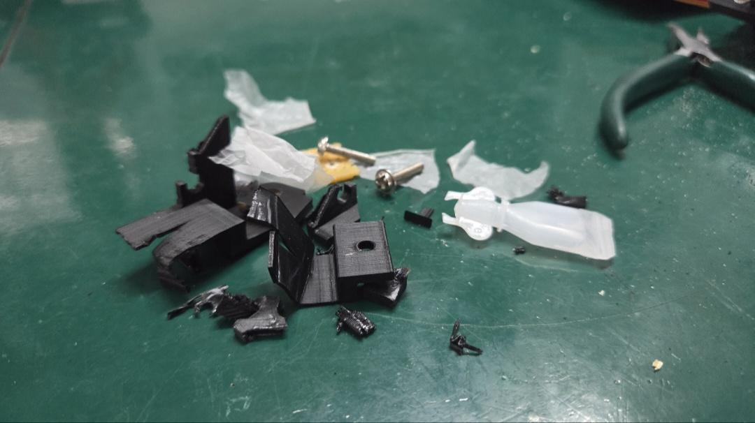

Rebuilding of product:-
- Reprinted the servo case.
- Also rewritten code for detection due to problems with the sensor.

Future scope:-
- It can have better wiring
- Can be well designed so it can be used for multiple MCBs

